Parker D. Lewis
Dr. Paul King
Nuclear Grad Lab
9/11/2024

Prelab 1: Abundance Lab

- For every chemical element in the periodic table, you can have different types of the same element which is called an isotope. Isotopes are different extensions of the same chemical element that differ in mass number (proton + neutron) but have the same atomic number (protons). So basically, it is the neutrons that are different in each isotope. An abundance of an element or by what it’s called, Isotopic Abundance is the percentage of that specific isotope existing or how it makes up a specific element of the universe. Certain examples like the element Carbon are mainly made up of Carbon-12 and Carbon-13. The makeup of those isotopes is approximately 98% and 1%. This shows that in nature each element is made up of its different concentrations of the same thing and some will be more prominent than others in the makeup. One of the main applications of abundances is to use these values and specific atomic masses of isotopes to do a summing product of atomic masses and abundances to describe atomic weight of an element.
For this lab the main element of interest is Uranium. Uranium is mainly made up of Uranium-234, Uranium-235, and Uranium-238. The corresponding abundances are 99.3 %, 0.7%, 0.01%. Another specific use is that in this lab we will measure a ratio of corrected counts of U-235 and U-238 to then be able to compare it to abundance of those isotopes and do a comparison. (Word count: 242 words)

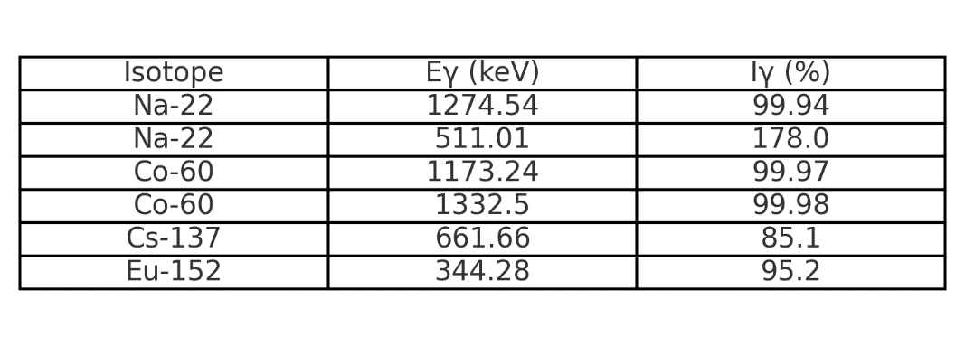
Fig 1. Expected Gammas and Intensities.

Work Cited
[1] Chatgpt, openai.com/chatgpt/. Accessed 11 Sept. 2024.
[2] “Gamma-Ray.” Idaho National Laboratory, 7 Dec. 2023, inl.gov/gamma-ray/.
[3] Radioactivity: Introduction and History: F. L’Annunziata, Michael: 9780444527158: Amazon.Com: Books, www.amazon.com/Radioactivity-Introduction-Michael-F-LAnnunziata/dp/044452715X. Accessed 11 Sept. 2024.
[4]

